CLASSIFICATION NORMAL AND ABNORMAL HEART SOUNDS USING SHORT-TIME FOURIER TRANSFORM AND CONVOLUTIONAL NEURAL NETWORK

Achmad Rizal1, Dian Rezky Wulandari, Penulis3, Penulis4, Penulis5

1Departement of Master Electrical Engineering, School of Electrical Engineering, Telkom University, Bandung 40257, Indonesia

achmadrizal@telkomuniversity.ac.id1, dianrezx@student.telkomuniversity.ac.id2, Emali 2, Email3

Abstract

A medical device that diagnoses the patient's condition by observing the patient's heartbeat with a stethoscope. Every sound produced by stethoscope has a unique pattern and it depend on condition of person’s heart. This technique also known as auscultation. Because auscultation is based on a doctor's experience and knowledge, researchers have automatically developed different methods to analyze heart sounds. In this research, we do classifying of normal and abnormal heart sound using XXXX.

Keyword

Introduction

Stethoscopes are used by medical personnel to listen to acoustic signals emanating from inside human organs [1]. Diagnosis includes examination of body parts: the lungs, heart, and intestines. The type and strength of the generated acoustic signal helps medical staff diagnose the patient's condition [2]. A stethoscope is an essential tool as it plays an essential role in diagnosing a patient's disease. The current observational process refers to the technique of listening to sounds from within the patient's body as auscultation [3]. This process uses a stethoscope to hear more precise sounds. However, this direct approach has many obstacles. These problems are low frequency, low amplitude, ambient noise, hyperacusis, and sounds with much the same pattern.

One of the signals that can be heard with auscultation techniques is the heartbeat. Doctors diagnose heart problems by hearing this sound. With these subjective factors in mind, many methods have been developed to automatically classify heart sounds using digital signal processing methods [4].

In general, heart sound signal processing can be divided based on signal regions such as time domain, frequency domain and time-frequency domain [5]. Signal processing in the time domain. B. Statistical features of heart sounds, empirical modal decomposition (EMD), and computation of fractal dimension [6]. On the other hand, the processing of heart sound signals in the frequency domain includes filter banks, frequency band average power, MFCC, quartile frequencies, and zero-crossing analysis [7]. Frequency-domain signal processing primarily uses the Fourier transform to convert a signal from the time domain to the frequency domain. Short-time Fourier transform (STFT), Wigner-Ville distribution (WVD), Stockwell transform (S-transform), Hilbert-Huang transform (HHT) or wavelet transform [ 5]. The use of the time-frequency domain is fairly common. This technique provides information about the frequency content of the signal at any point in time.

Since the time-frequency domain method described above only changes the signal from the time domain to the time-frequency domain, we need to use feature extraction methods to preserve the properties of the signal. One way to do that is signal complexity. kings. We used wavelet temporal entropy to separate normal and abnormal heart sound signals [8]. Other researchers have used the fractal dimension to distinguish between normal heart sounds and heart murmurs [9]. Short-time Fourier transform (STFT) as a method of transforming 1D signals into the time-frequency domain has also been used in previous work. STFT and tensor decomposition were used by Zhang et al. Proposed. as a feature of normal and abnormal heart sounds [10]. On the other hand, wavelet entropy is used as a feature of his STFT from unsegmented signals of heart sounds [11]. The properties in all previous studies were calculated directly with STFT. No analysis of dissemination of information on STFT was performed.

In this study, we propose a new method to classify normal and abnormal heart sounds using STFT and gray-level difference method (GLDM) as feature extraction methods. STFT has been used to change the time domain to the time-frequency domain [12]. Next, we analyze the heart sounds with the GLDM texture analysis method [13]. Heart murmur, a 1D signal, is transformed to 2D using STFT and analyzed using GLDM. GLDM is a feature extraction method that displays the texture of an image by creating a new image that is the absolute value of the difference between two pixels at a specific distance and direction. GLDM creates a new image in which the texture can be observed, as it is calculated from the absolute value of the difference between two pixels. Then some statistical parameters are calculated. This differs from other texture analysis methods such as: B. Grayscale co-occurrence matrix (GLCM) and grayscale rung length (GLRL) [14]. A GLCM calculation does not create a new image, but rather a co-occurrence matrix that is the result of computing the number of occurrences of pixel values ​​at a specified distance. GLRL, on the other hand, produces run-length encoded code that describes pixel values ​​and their repetitions [15]. GLCM and GLRL results are not images and cannot be evaluated directly visually. Hopefully, this proposed method will be an alternative to biosignal processing methods obtained by exploiting spatiotemporal information from signals.

The rest of this work is organized as follows. The proposed method is described in Section 2. Experiments, results, results and deeper analysis are then described in Section 3. Section 4 at the end of the contribution presents conclusions and potential for future research.

Materials and Methods

Jelaskan langkah-langkah penelitian baru masuk ke teori dari metode yang akan kita gunakan pada subsection

Jika dibutuhkan diagram blok system keseluruhan ditampilkan disini dan dijelaskan secara ringkas dan dijelaskan lebih rinci di subsection selanjutnya

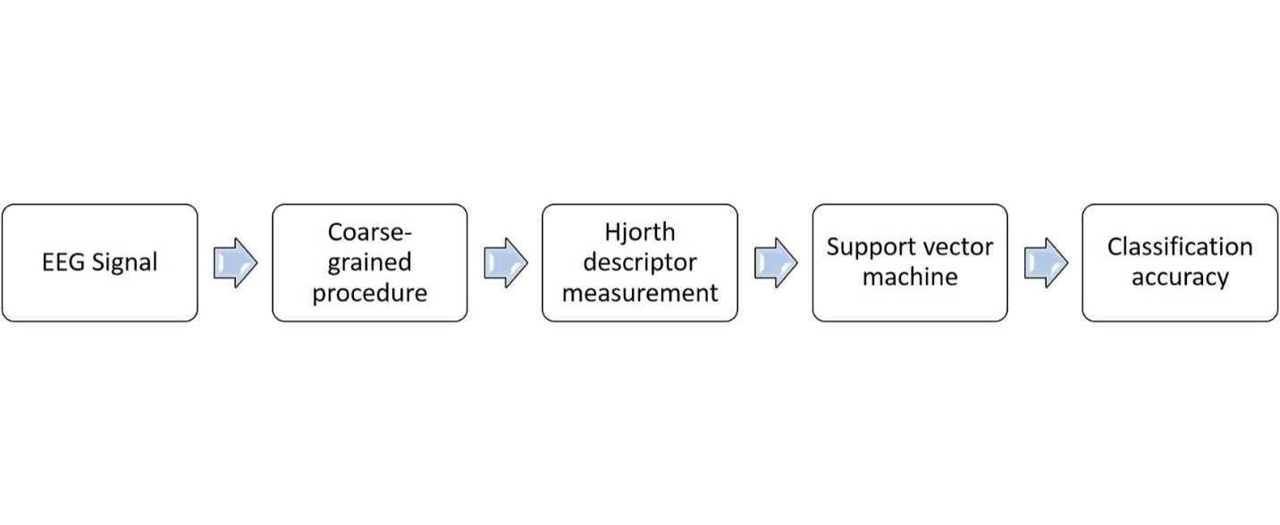

Figure 1 Diagram block of proposed method

(berikan gambar supaya mudah mengarahkan pembaca ke apa yang kita lakukan )

2.1 Data

Misalnya berikan penjelasan data yang dipakai, bagaimana cara mendapatkannya. Misal jumlah data, subject, frekuensi sampling dll. Boleh diberikan plot gambarnya

2.2 Preprocessing

Metode apa yang dipakai dalam penelitian ini.

Short Time Fourier Transform

STFT adalah metode untuk menganalisa frequensi sinyal dan menjadikan sinyalnya tersebut tersegmentasi pada interval waktu tertentu. Sinyal tersegmentasi ditransformasikan menggunakan Fast Fourier Transform (FFT) ke domain frekuensi. Dengan STFT akan menampilkan sinyal masukkan dengan rentang waktu dan frequency menggunakan window function. Perhitungan STFT secara matematis dapat ditulis sebagai berikut :

$XSTFT \left[m,n\right]= \sum_{K=0}^{L-1}{x\left[k\right]g\left[k-m\right]e^{-j^{2πnk/L}}}$ (2)

Yang mana x(k) merupakan sinyalnya dan g(k) merupakan L-point window. jadi STFT bisa dikatakan sebagai fourier transform dari sinyal x(k) yang mana telah menggunakan fungsi window g(k). Parameter yang digunakan dalam proses STFT sebagai media klasifikasi ialah sebagai berikut ini: Window function Keiser, Window dan overlap length: 25-20, 200-100, dan 500-475. FFT 512 dan 256

Convolutional Neural Network (CNN)

Results and Discussion

Tampilkan hasil yang didapat dan berikan penjelasan dan analisis yang mencukupi. Langkah paling mudah ialah menampilkan keluaran dari tiap proses pada Material and Method dan jelaskan.

Dibagian akhir berikan perbandingan, kelemahan dan kelebihan metode kita dibandingkan dengan metode orang lain

Berikan kemungkinan pengembangan atau penelitian ke depan terkait dengan penelitian ini

Conclusion

Kesimpulan dari penelitian ini , sebaiknya bukan berupa point-point tetapi uraian

References

[1] R. Afthoni, A. Rizal, and E. Susanto, “Proportional derivative control based robot arm system using Microsoft Kinect,” 2013 International Conference on Robotics, Biomimetics, Intelligent Computational Systems, pp. 24–29, Nov. 2013, doi: 10.1109/ROBIONETICS.2013.6743572.

[2] M. Al-batah, “Automatic Diagnosis System for Heart Disorder using ESG Peak Recognition with Ranked Features Selection,” International Journal of Circuit, Systems and Signal Processing, vol. 13, 2019.

[3] G. Serbes, C. O. Sakar, Y. P. Kahya, and N. Aydin, “Pulmonary crackle detection using time-frequency and time-scale analysis,” Digital Signal Processing: A Review Journal, vol. 23, no. 3, pp. 1012–1021, 2013, doi: 10.1016/j.dsp.2012.12.009.

[4] A. Cunha, L. Pádua, L. Costa, and P. Trigueiros, “Evaluation of MS Kinect for Elderly Meal Intake Monitoring,” Procedia Technology, vol. 16, pp. 1383–1390, 2014, doi: 10.1016/j.protcy.2014.10.156.

[5] Y. S. Choi, “Information-theoretical quantifier of brain rhythm based on data-driven multiscale representation,” Biomed Res Int, vol. 2015, 2015, doi: 10.1155/2015/830926.